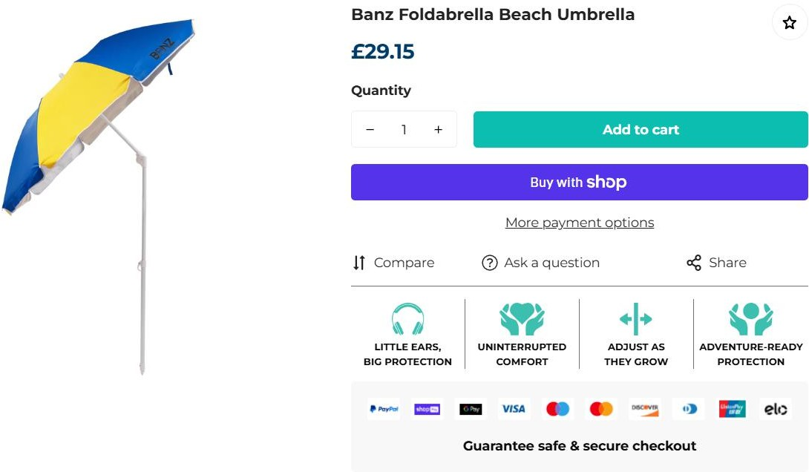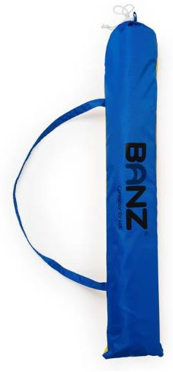
3,991pcs x Banz Foldable Beach Umbrella……….RRP £29.15

